American Relocation Alliance Presents
2024 Conference
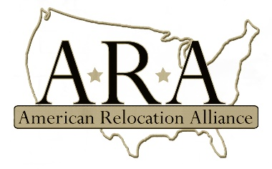
Drury Plaza
300 Korean Veterans Blvd, Nashville, TN 37201
August 27th & 28th

PLATINUM Package $1,500.00*
- Conference Package including meals/reception/networking for two attendees
- Sponsorship mention & signage at General Session
- Prominent placement of exhibit table
- Speaking time at general session 5-minute introduction
- Opportunity to provide education session for members during the event (content and subject matter to be approved by board)
- Link to homepage from www.americanrelo.org
- Collateral disbursed in conference packets
- Mention and information promoted through ARA workplace and Facebook (must provide desired content and approval by board is required prior to posting)
GOLD Package $1000.00*
- Conference package including meals/reception/networking for one attendee
- Sponsorship mention & signage at General Session
- Speaking time at general session 5-minute introduction
- Link to homepage from www.americanrelo.org
- Collateral disbursed in conference packets
- Exhibit table provided
SILVER Package $750.00*
- Conference package including meals/reception/networking for one attendee
- Sponsorship mention at General Session
- Exhibit table provided
- Logo displayed on www.americanrelo.org
- Collateral disbursed in conference packets
* Please note: Room and transportation are not included with your conference fees; space is limited so book your room early to obtain the ARA discounted room rate. There may be additional charges for internet hookup if needed depending on hotel policies.
Hotel Information:
Room Rate: $239/night. Reservations made by individuals calling 800.325.0720 and referring to group number 10071088 or https://www.druryhotels.com/bookandstay/newreservation/?groupno=10071088
Airport:
BNA – Nashville International Airport – 8 Minutes from Drury Plaza
2024 ARA BOARD SPONSORSHIP CONTACT: Kim Yeoman – 630-303-4939
Email: americanrelocationalliancec21@gmail.com

